Portal for Food ordering

**Project Report**

*Submitted in fulfilment for the J-Component of ITE1008 – Open Source Programming*

**CAL Course**

***in***

**B.Tech. (Information Technology)**

*by*

**Praful Garg(19BIT0161)**

**Aniket Kumar(19BIT0035)**

**Patan Mohammad Adnan Khan(19BIT0197)**

**Akkichetty Nithin Sai(19BIT0223)**

*Under the guidance of*

**Prof. Jayakumar Sadhasivam**

**SITE**



**School of Information Technology and Engineering**

Winter Semester 2020-2021

**TABLE OF CONTENTS**

|  |  |  |
| --- | --- | --- |
| **CHAPTER NO.** | **TITLE** | **PAGE NO.** |
|  | Abstract | **3** |
|  | Introduction | **3** |
|  | Problem statement | **4** |
|  | Modules | **4** |
|  | Process Flow Diagram | **5-8** |
|  | Prototype Design | **9** |
|  | Database Design | **9-13** |
|  | Conclusion | **13** |
|  | References | **13** |
|  | Snapshots | **14-22** |
|  | Source Code | **23** |

**Abstract:**

With the expanse of technology and knowledge, more people are getting connected to internet. Food Ordering on internet has gain a big interest in metropolitan cities like Delhi, Mumbai, Bengaluru, Chennai etc. Big Firms like Zomato and Swiggy are not available in small cities, semi-urban or rural areas and in this pandemic period where people are not suggested to leave their home is a big blow to restaurants and fast-food centre. Solution to the given problem is to provide an alternate platform where customers can place orders to their favourite restaurants without any sacrifice to their taste buds. The technique is to provide restaurant owners a platform to expand their business, if restaurants doesn’t have a delivery boy, then our team can provide them with other agents. Currently the restaurants which have tie up with Zomato have their separate delivery boys. The problem here is that the same cannot be possible for a small city, because it might be expensive to keep delivery agents from both Zomato and their shop exclusive. The technique, we are going to use is a portal for both customer and restaurant. Customer can see all the restaurants connected to our service and Restaurants can receive feedback for each order. They can change the menu, increase or decrease price, etc. If the shop doesn’t have a delivery man, then we can provide it for weekly basis. Hence, they don’t need to take our delivery boy in order to use are portal. By this project, we are going to use our knowledge of PHP to implement it on our project, which is Portal for Food Ordering. For future, the project can be upgraded to deliver food to the orphanage or provide donation to food NGOs near your city.

**Introduction**

Portal for Food Ordering provides customers for a way to place an order at a restaurant over the internet in this pandemic period. The main reason is that it benefits both the customer and the business, customers can easily browse all the dishes the restaurant has available, customize dishes to their requirements and place an order. It can also save their favourite orders allowing them to easily re-order that in the future. From the restaurant’s perspective, they no longer spend time taking the customer’s order, stop worrying about communication errors and streamline their order management workflow. Project has been made by all the 4 members ideas through prior discussion and brainstorming. Every member of the group has contributed in the project through multiple brainstorming session. The Report will further elaborate on the project.

**Problem statement**

Mostly people don’t like choosing a specific dish from the menu within few minutes while sitting inside the restaurant as it is too much confusing. They want time in order to go through the menu so that they can make a better decision. People are allowed to choose food only from a limited number of items mentioned in the menu. But when it came to online platform, they got so many choices.

**Modules**

* Administrator module
* Customer Module
* Restaurant Module

**Administrator module**

This module is used to create usernames and passwords by admin. Admin can view all the information about the user or delete or edit all the details about the restaurant.

**Customer Module**

* View product’s list
* Register
* Place orders

**Restaurant Module**

* Create product categories and functionalities
* Edit / delete product categories and descriptions
* View and manage orders and sales report.

**Process Flow Diagram**

Restaurant Console can have the details of restaurant status whether it is opened or closed with time, location and mobile number.

Restaurant can also have the details of menu and list of food.

It can have a functionality of creating a product and some operations.

It can have edit and delete categories.

Can View and Manage Orders received from the customer console.

Administrator can edit, delete or update the user details.

Admin can edit all the details of restaurant.

This is the main console to handle all operations in Customer and Restaurant Consoles.

In the customer application. Users can register and registered users can make changes to proﬁle and can order food and can rate the restaurant from where they got order.

Also the registered users can see the listed products in the restaurant and status of the menu items and also the status of the restaurant whether it is opened or closed.

After placing an order, it get stored in the restaurant console so they can see the order details with the phone number of the user.

Restaurant Console

Administrator Console

Customer Console

Web Application

**Customer Module**

Confirmation from Restaurant

Payment

Food added to cart

List of Restaurants

Sign Up/ Login

Customer Console

Order Status

**Restaurant Module**

Accept/Reject orders

Update menu

Login

Restaurant Console

Update order Status

**Administrator module**

Administrator Console

Edit/Delete/View

View

User

Restaurant

**Prototype design**

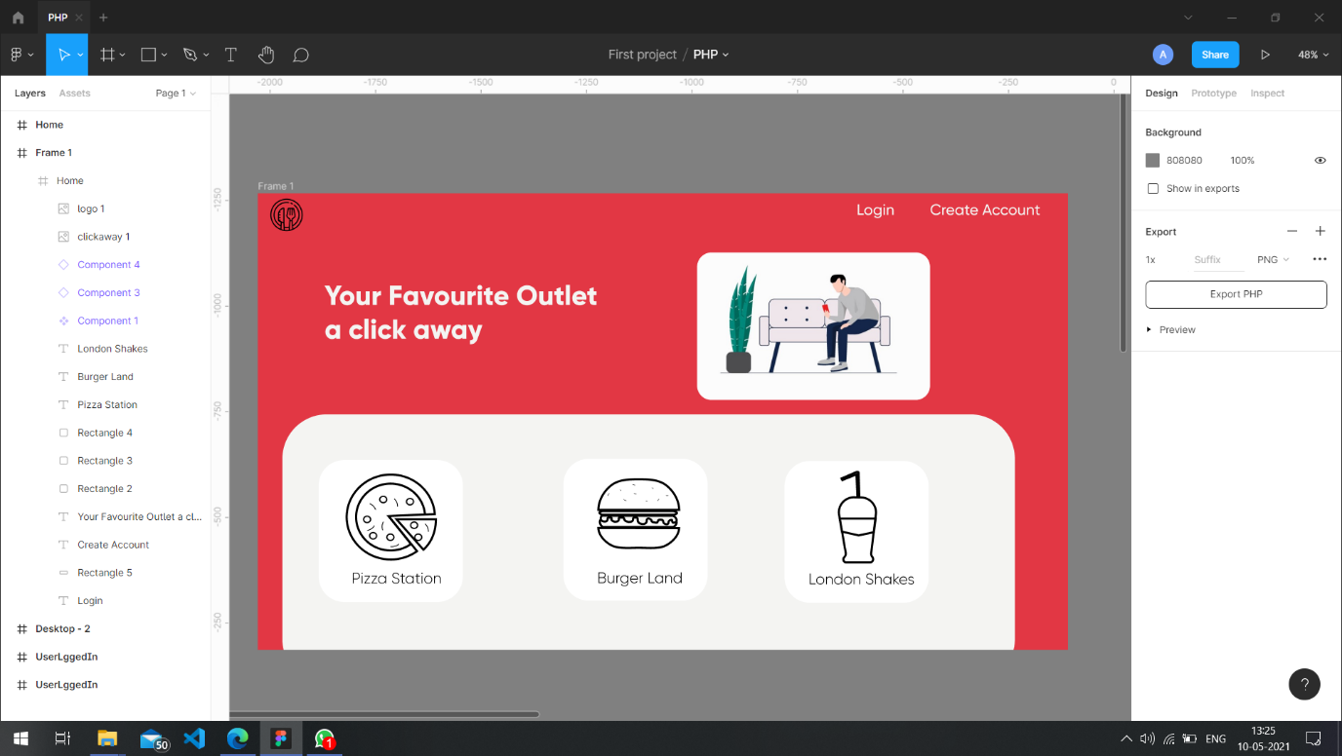

**Database Design**

**ER Diagram**

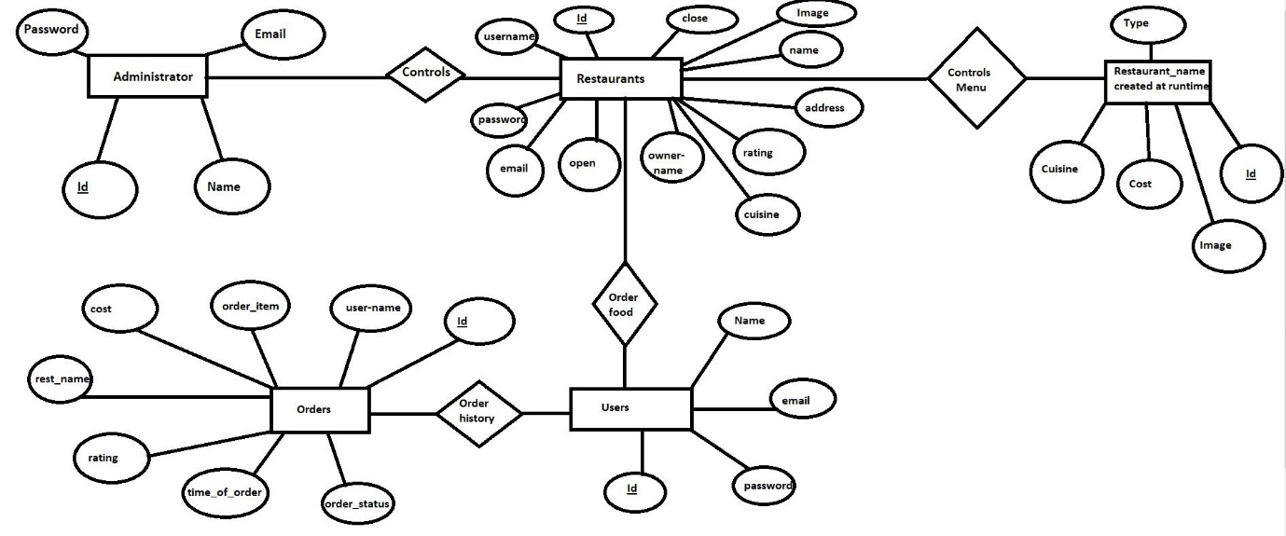

**Database:**

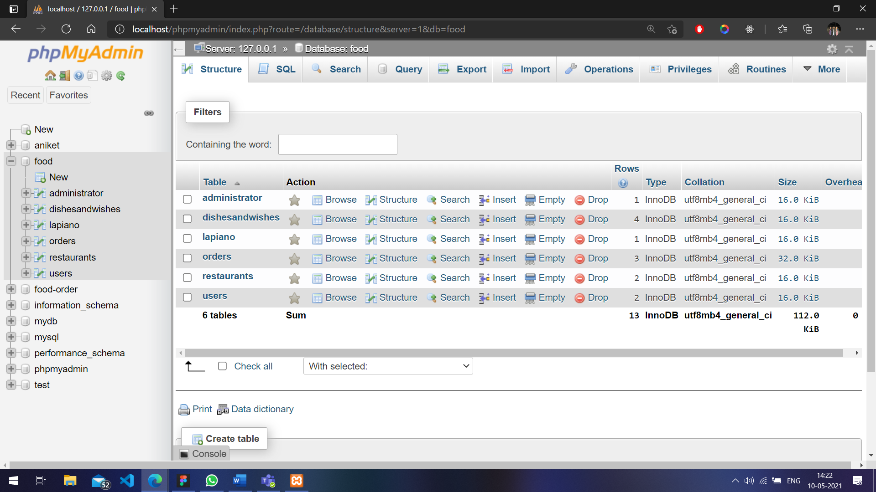

**Administrator Table**

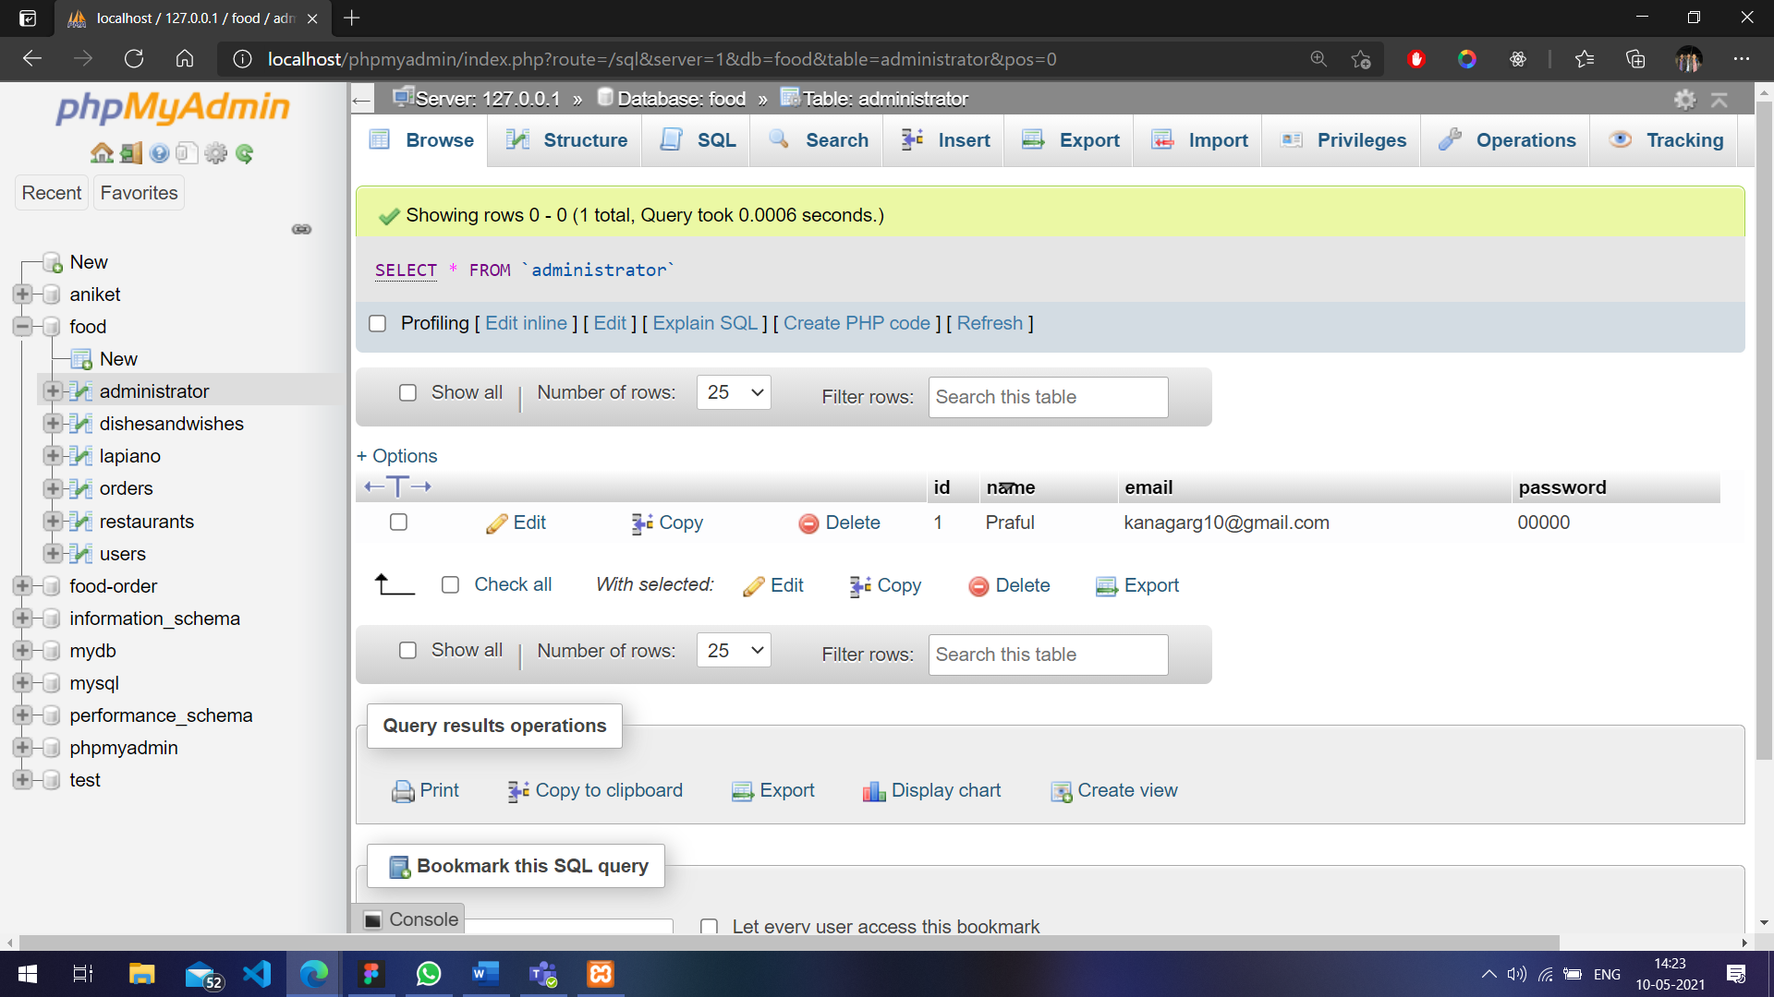

**Dishesandwishes Table**

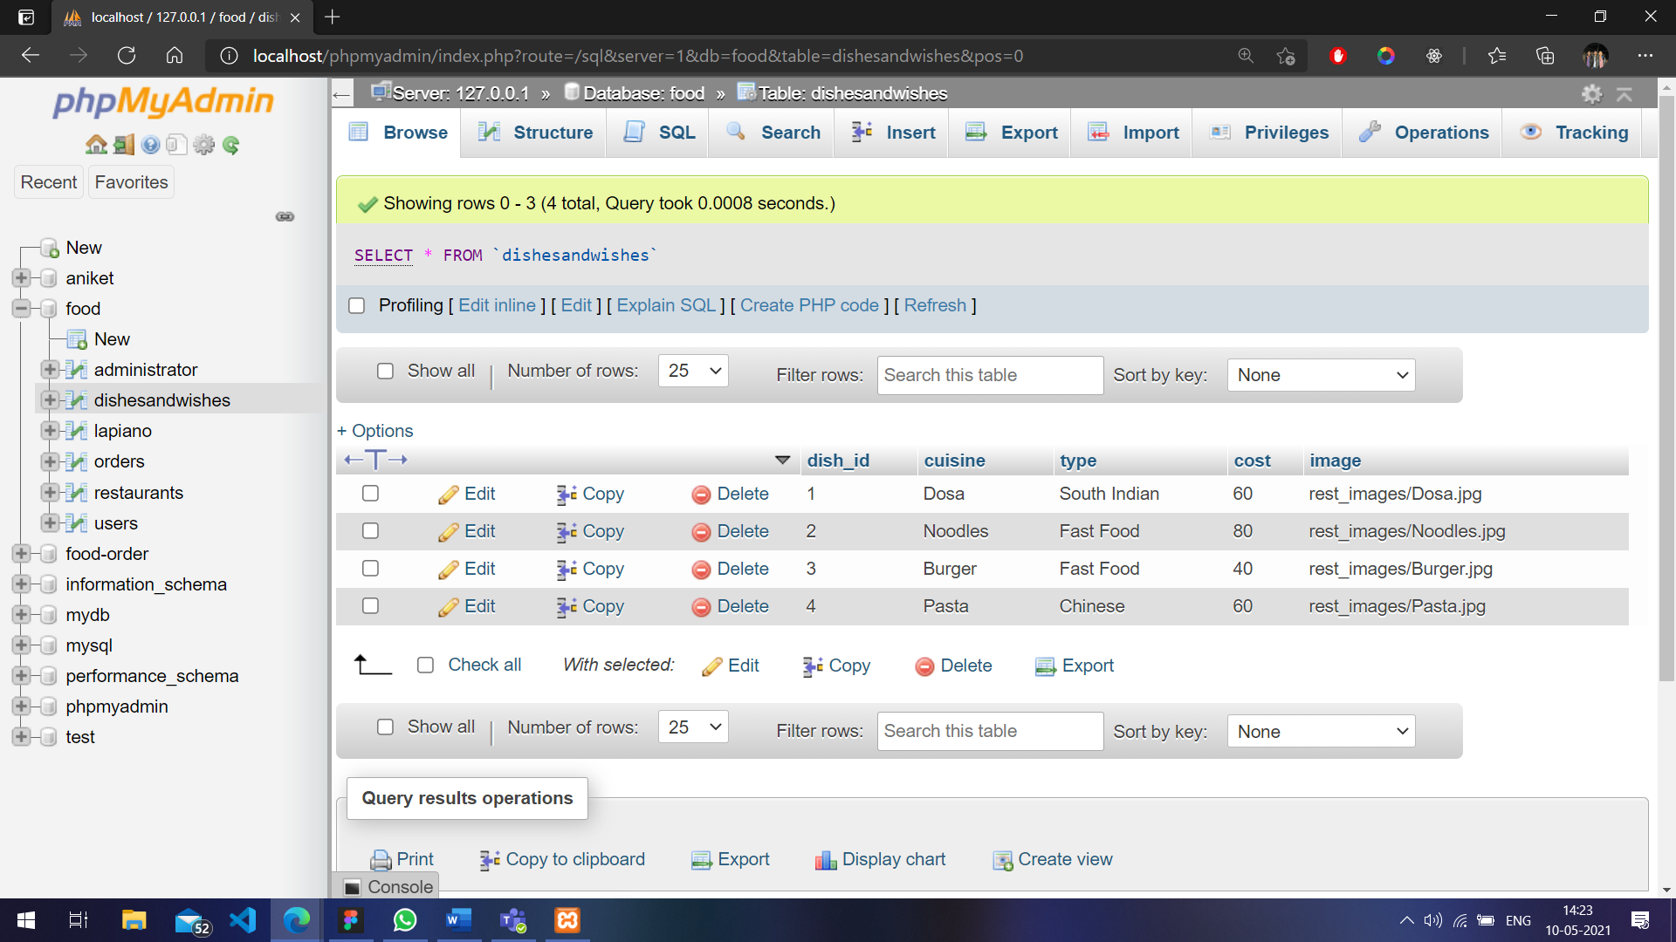

**Lapiano Table**

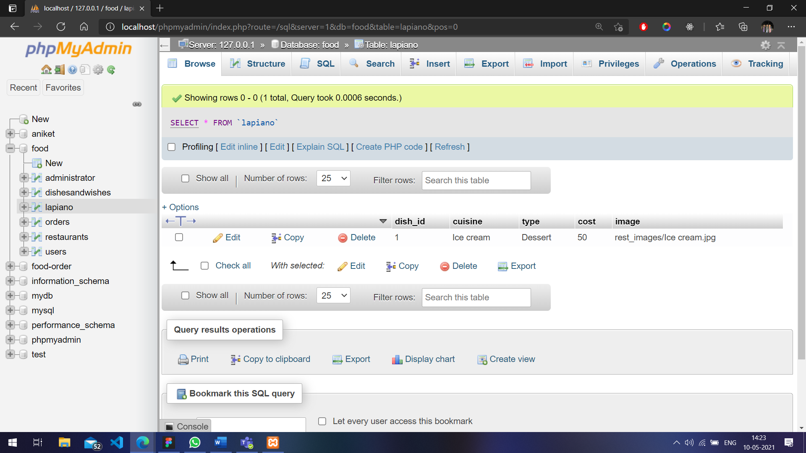

**Orders Table**

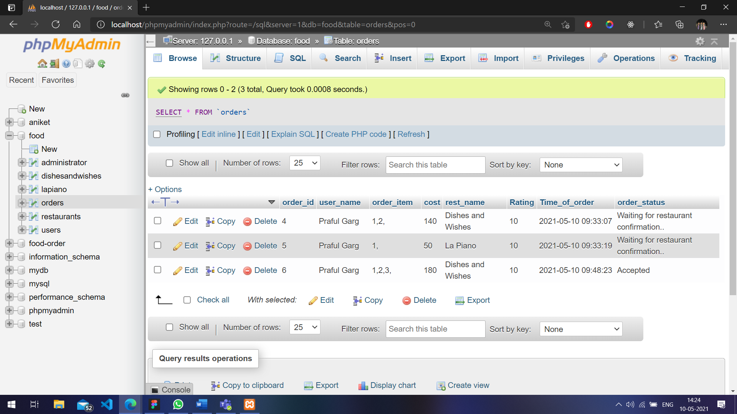

**Restaurants Table**

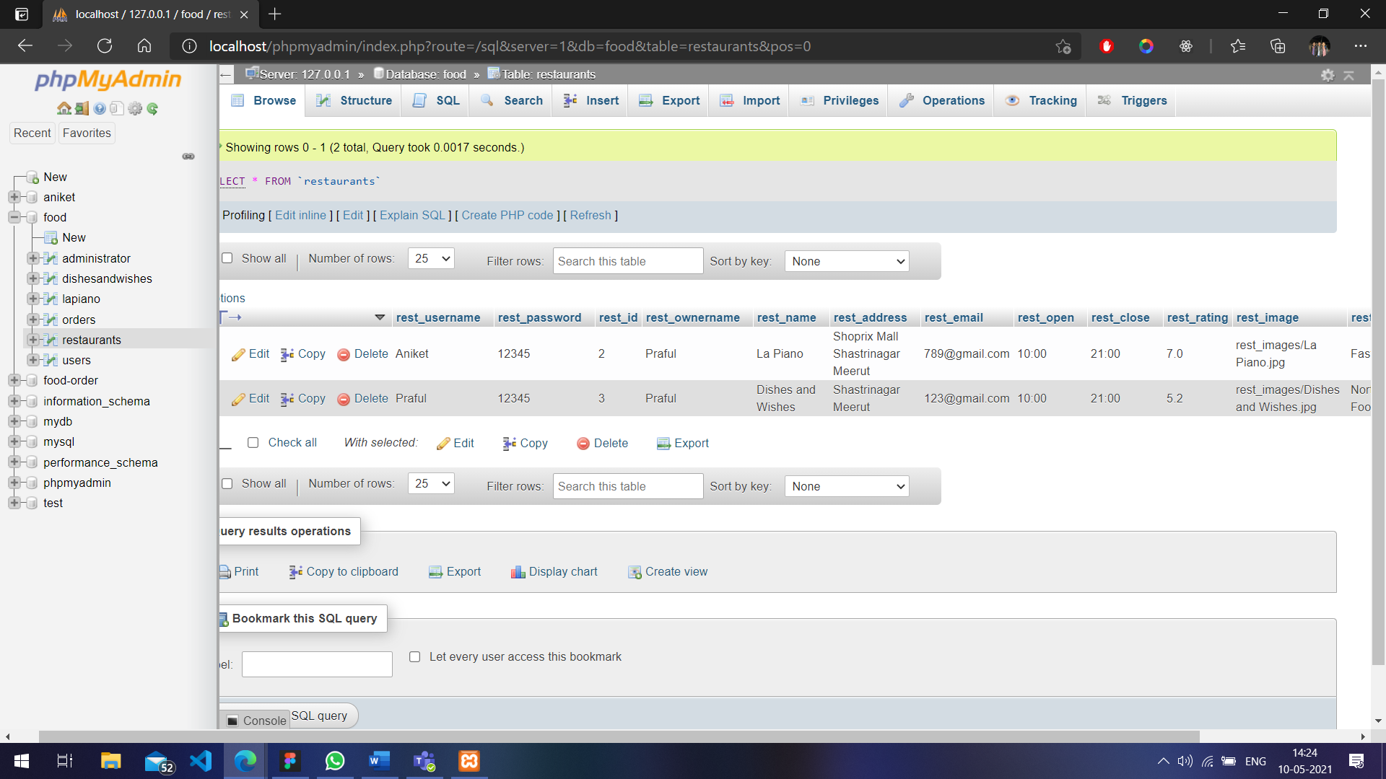

**Users Table**

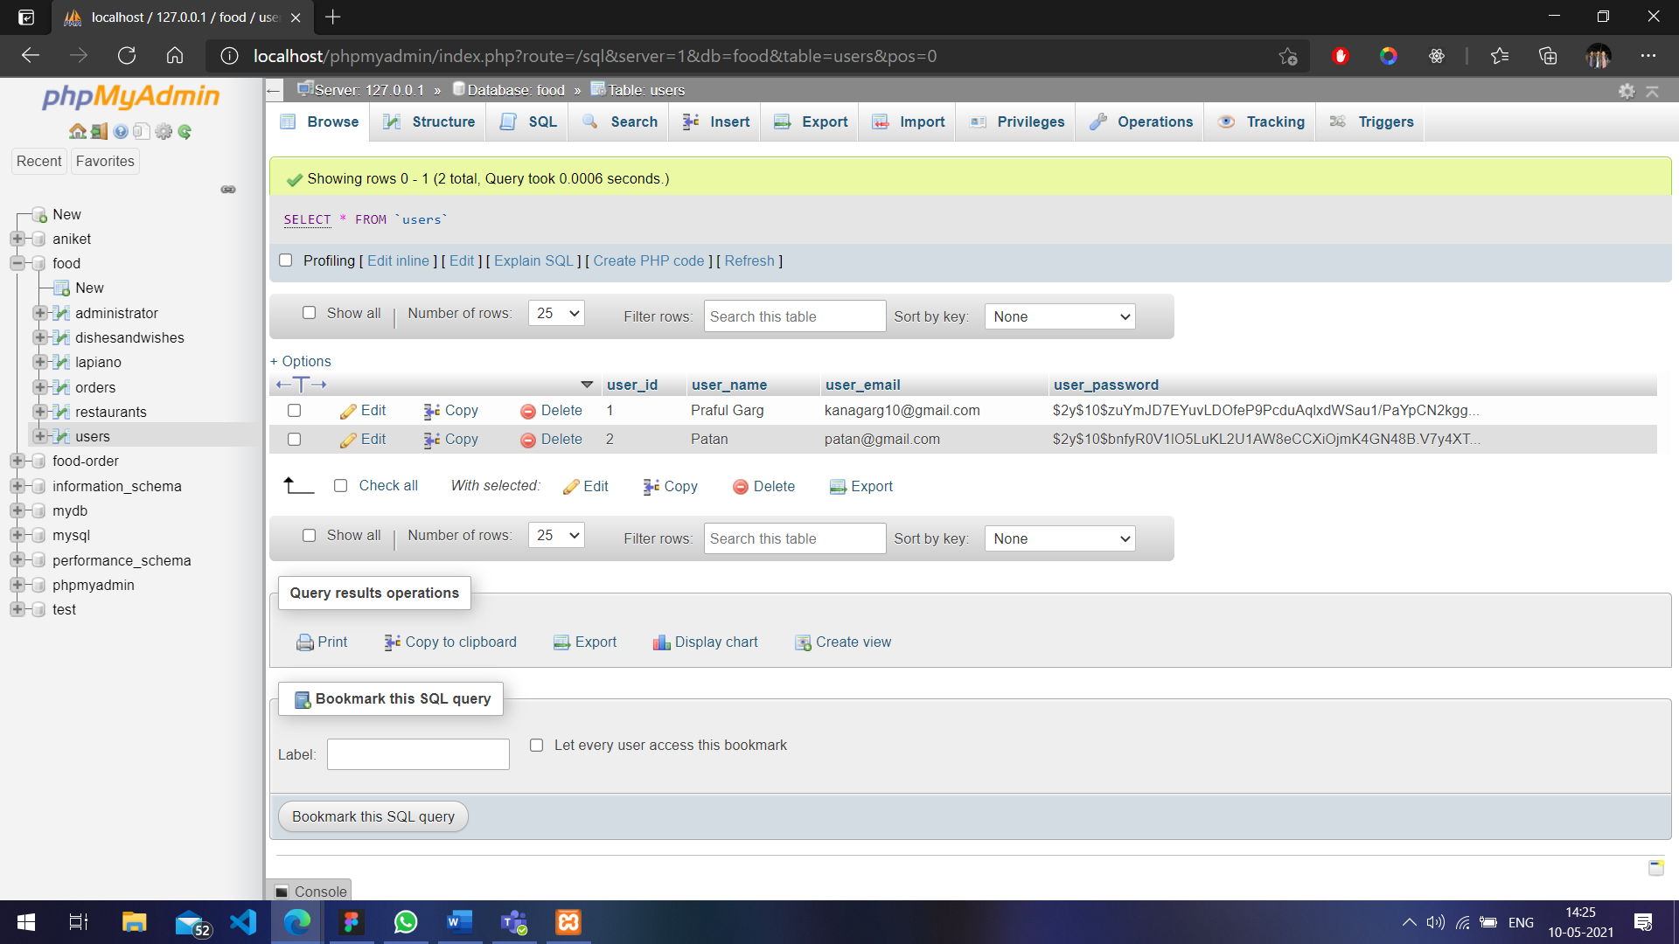

**Conclusion:**

Hence, it is concluded that portal for food ordering is a better and easier way to eat and enjoy our favourite food from the comfort of our home. We are glad to make our first PHP project on Food ordering portal under the guidance of Jayakumar Sir.

**Reference**

Representational images were taken from dribble. Food Images were taken from Unsplash and Google Main font used in our project is Gilroy and Lato. Colours primarily used are Cranberry, Peppercorn and Feta.

**Snapshot**

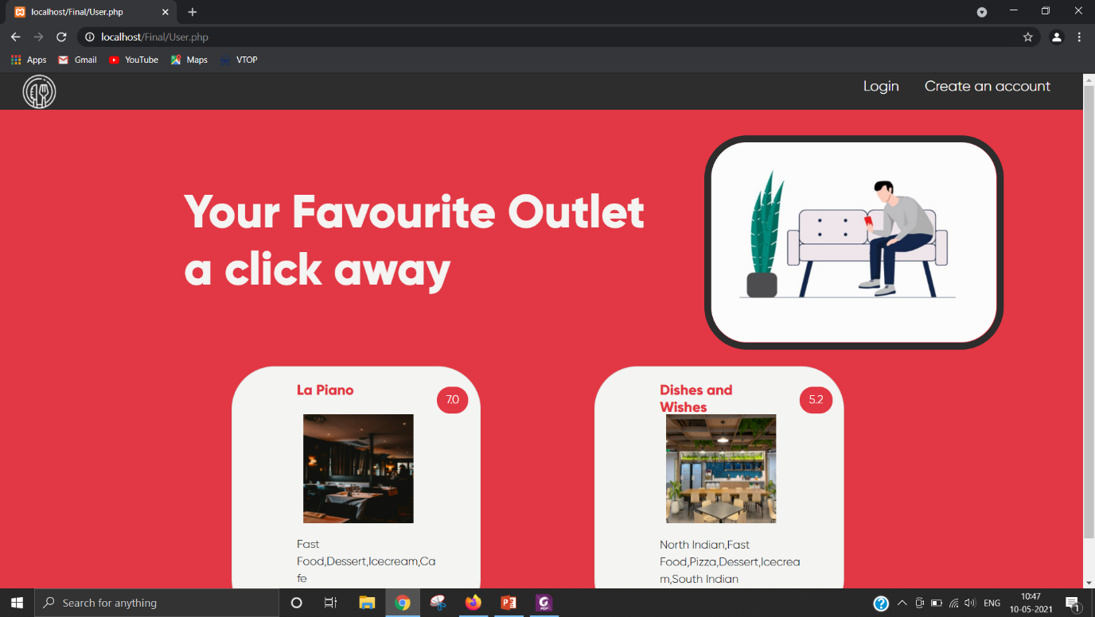

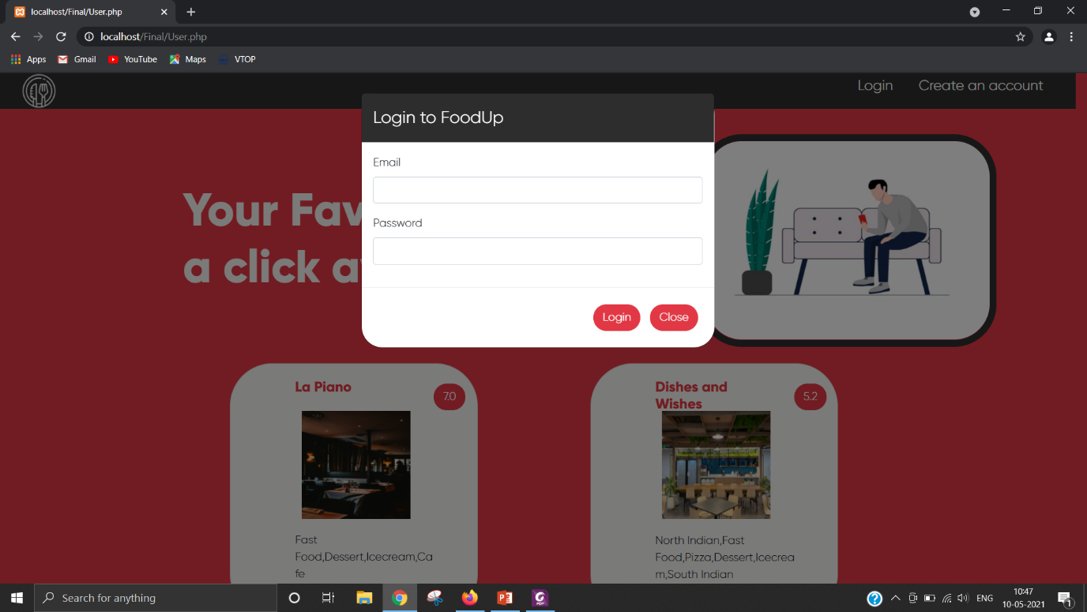

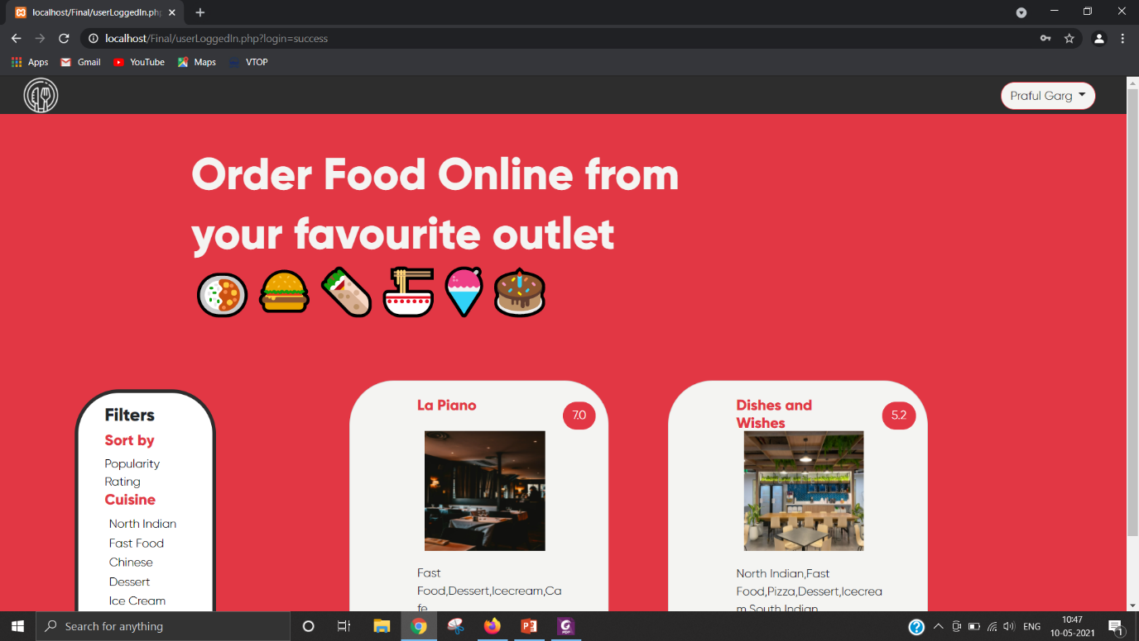

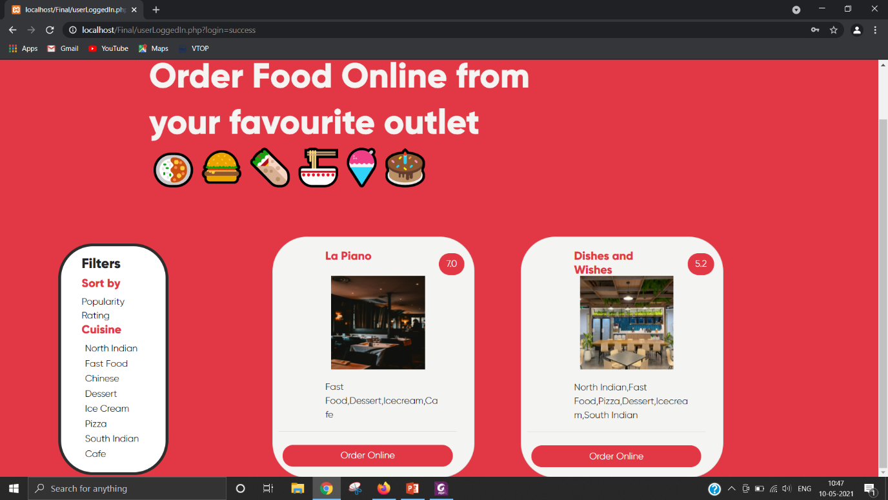

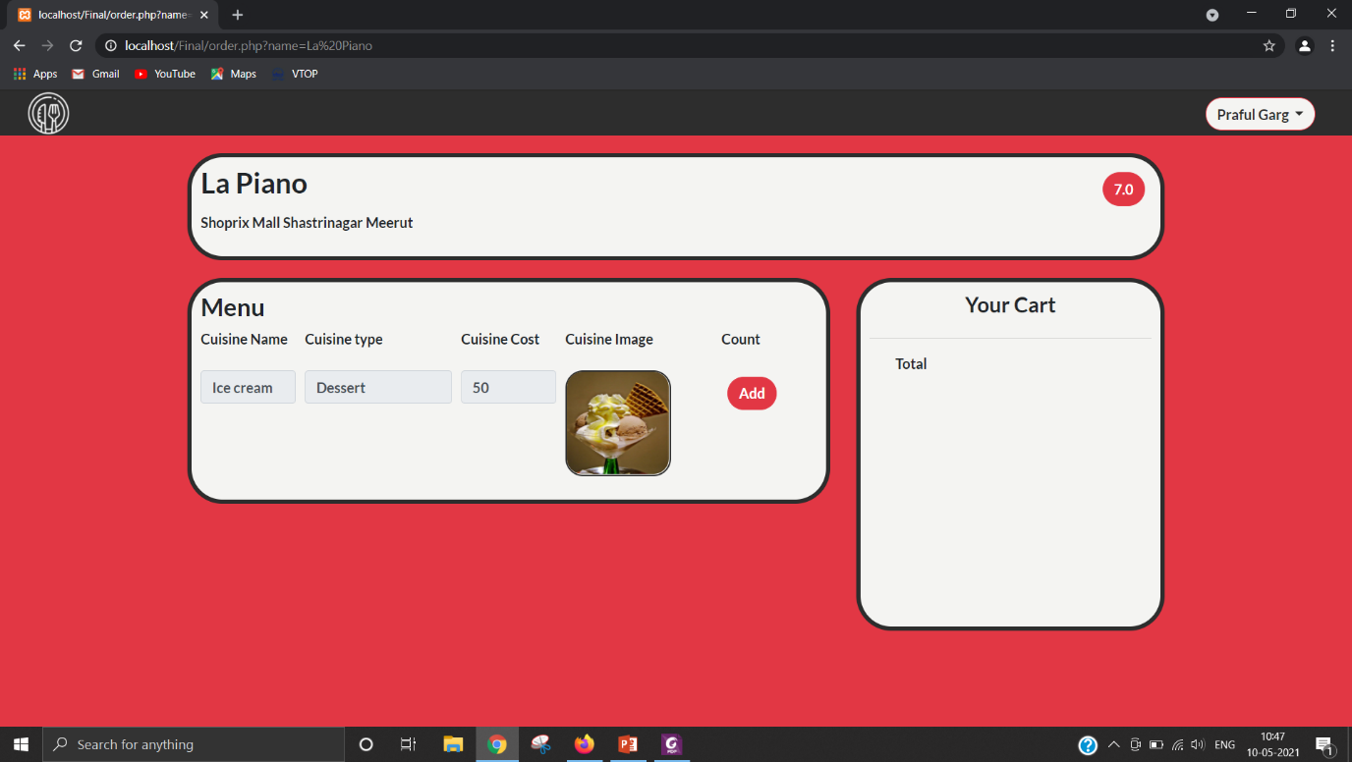

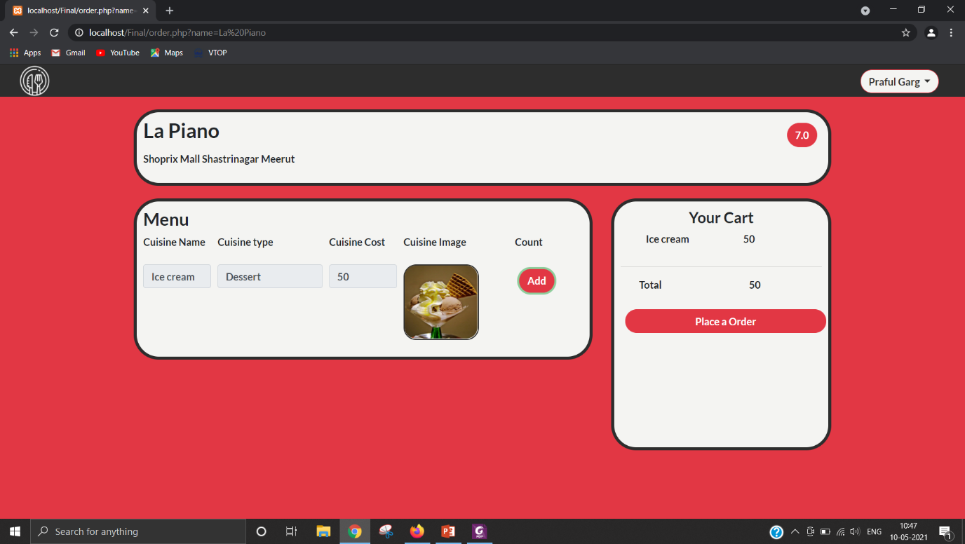

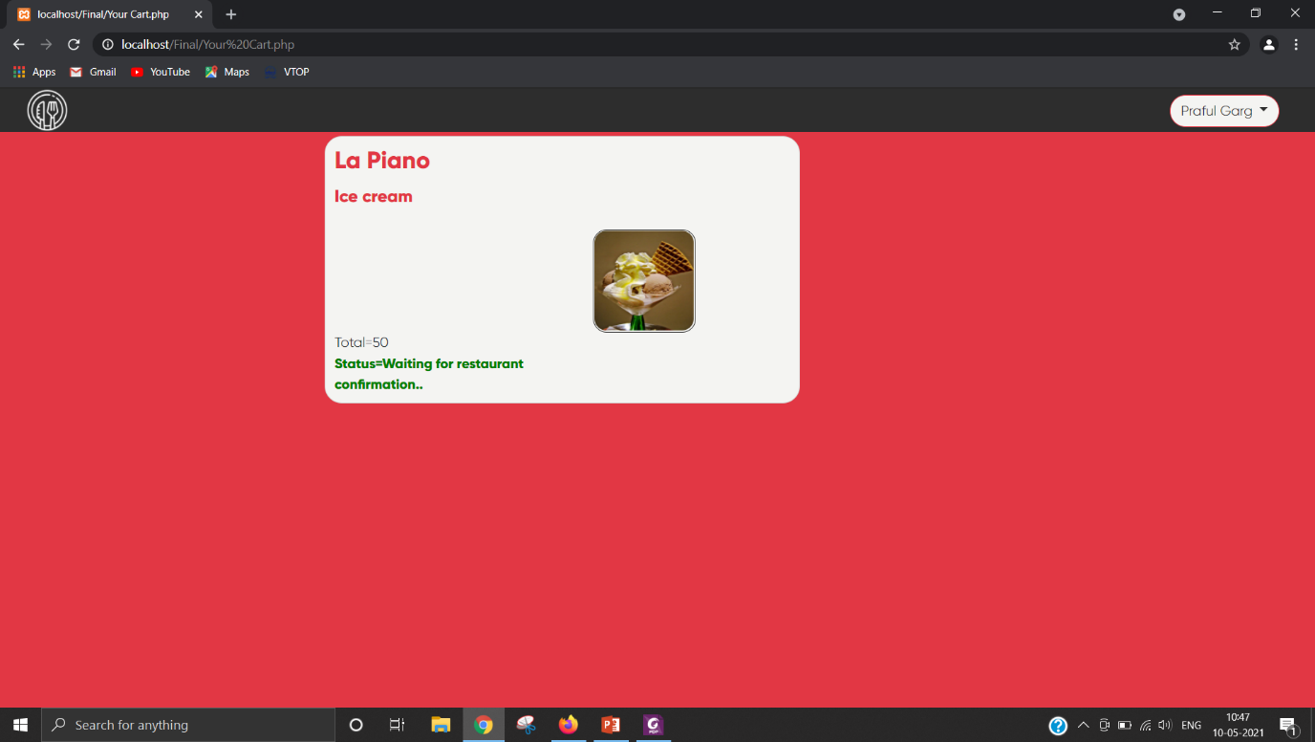

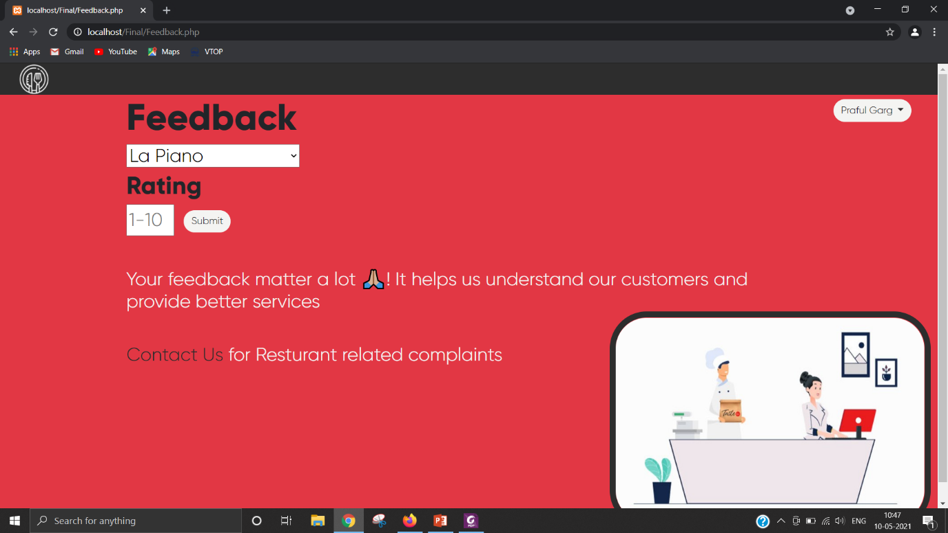

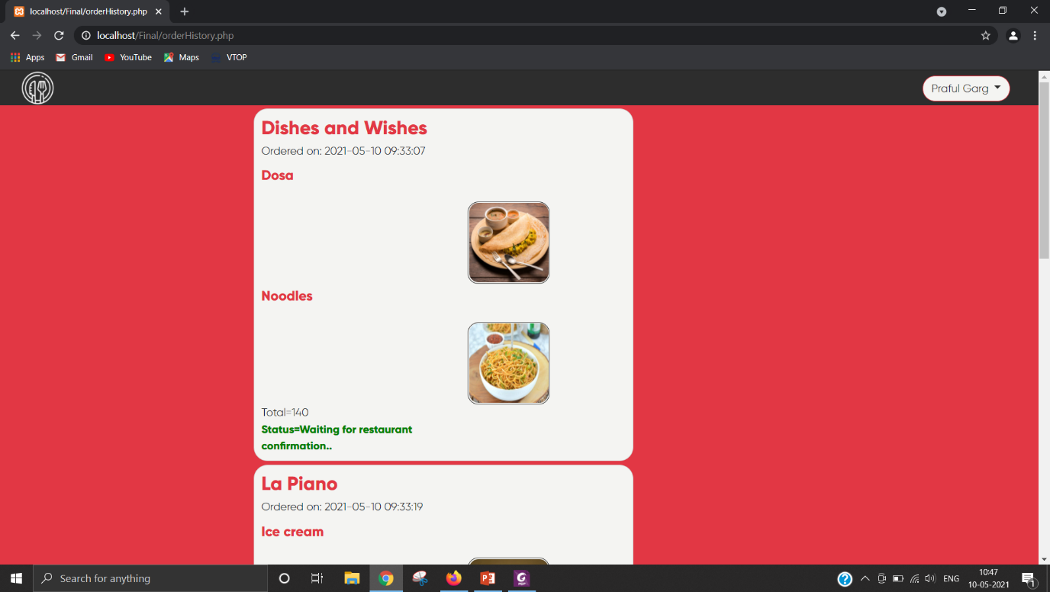

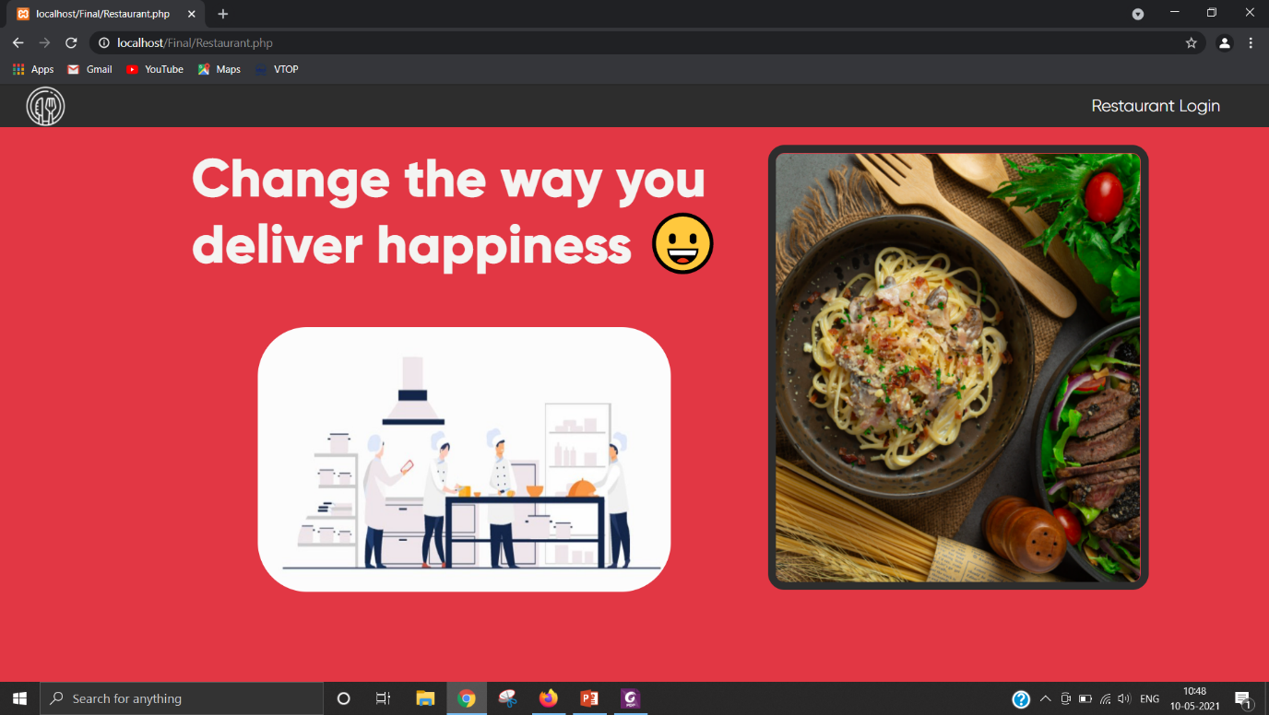

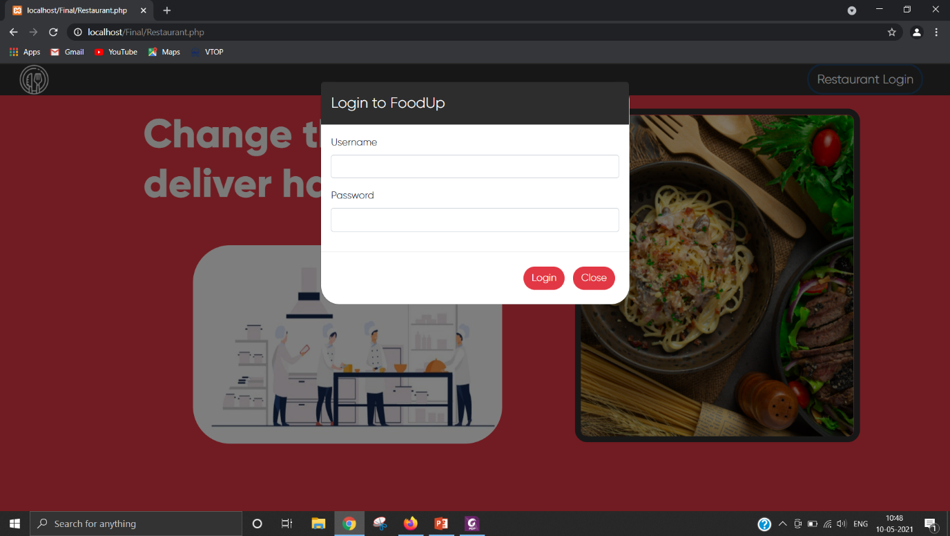

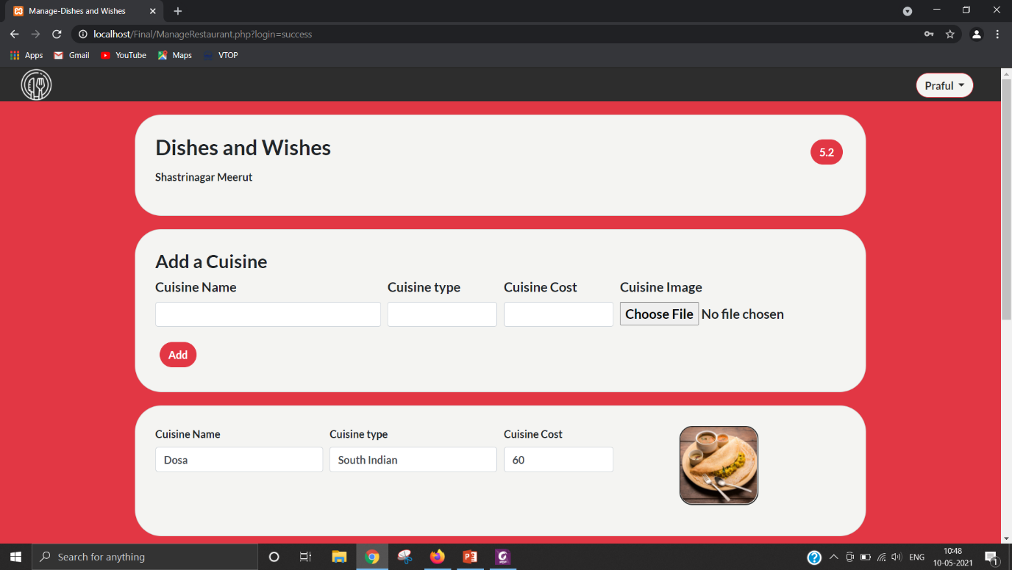

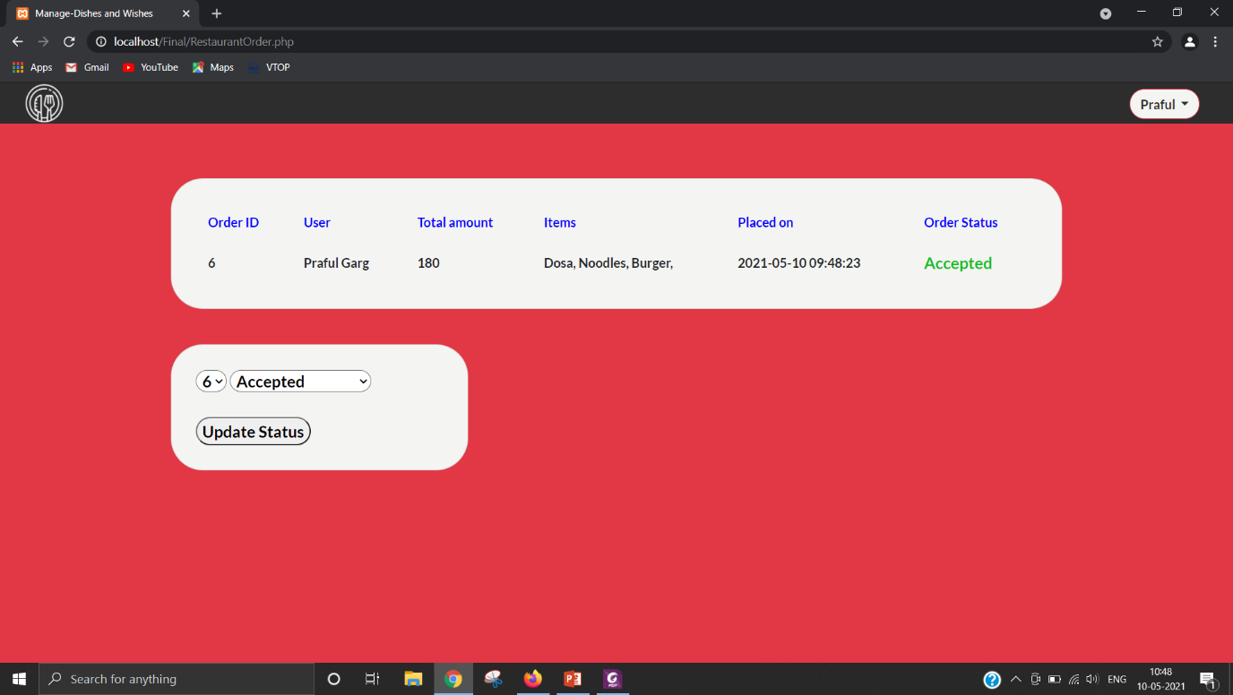

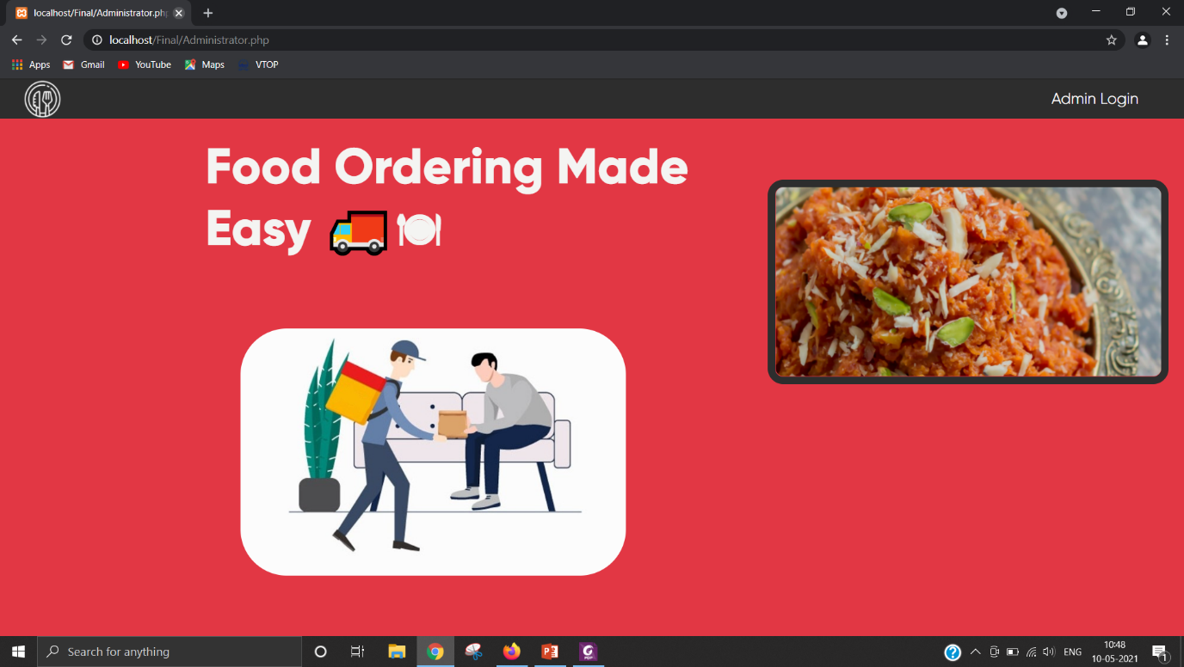

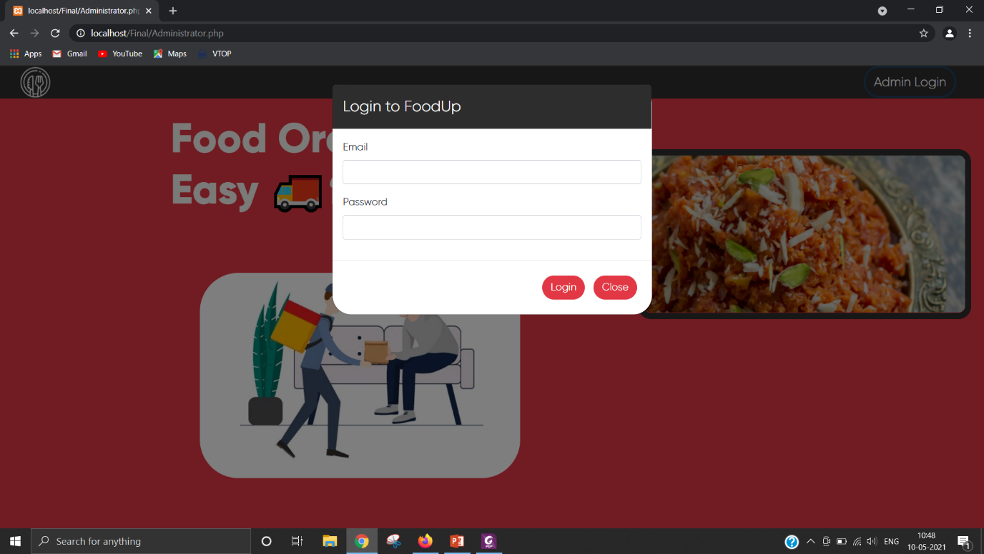

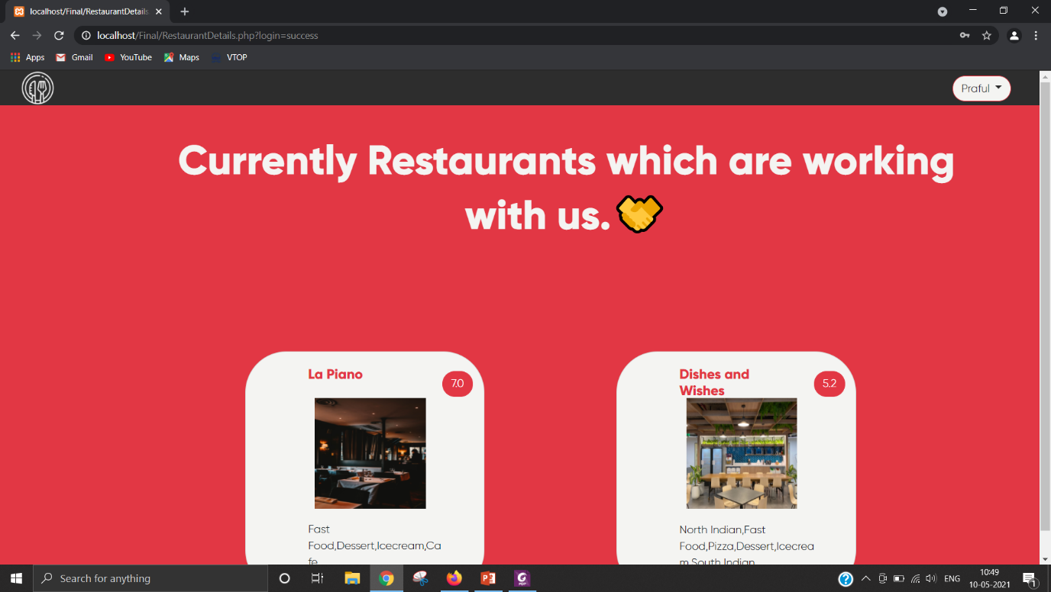

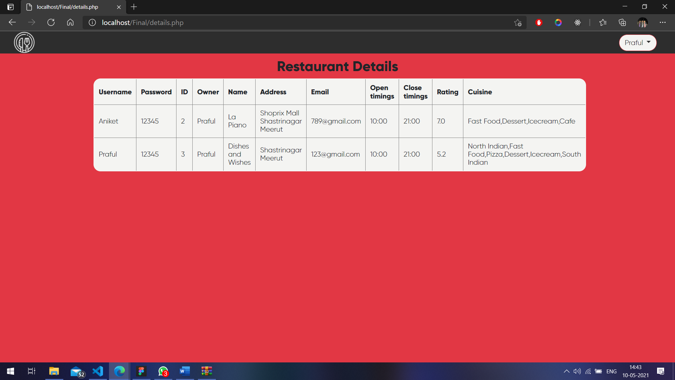

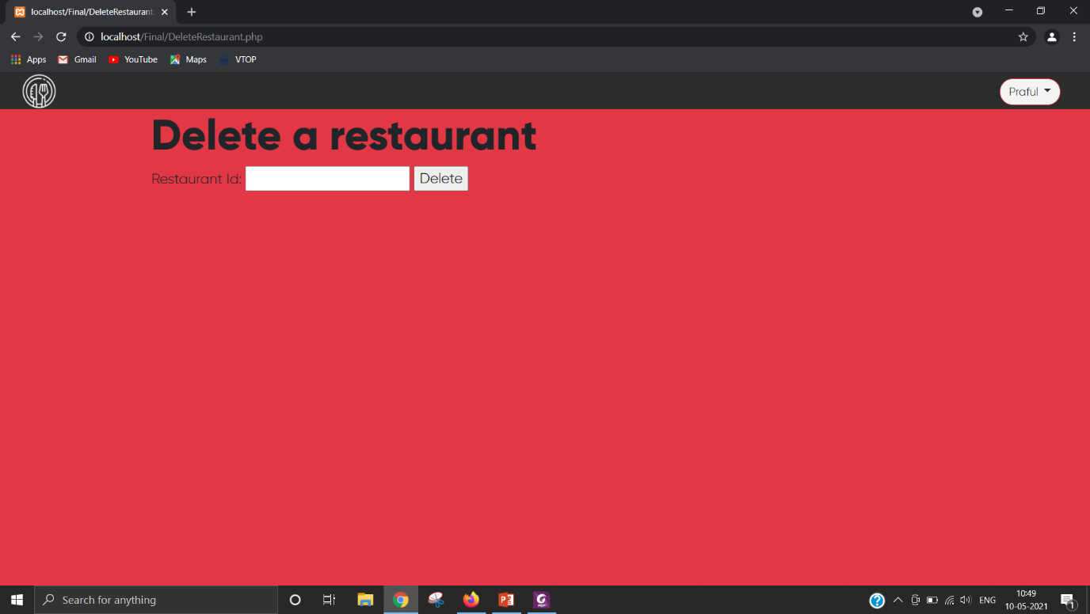

**Source code:**

<https://github.com/JayakumarClassroom/ws20-21-ite1008-a1-project-19bit_0035_0161_0197_0223/tree/main/Final>  
  
Home Page(User.php):

<?php

include 'includes/dbh.inc.php';

$sqlRest = "SELECT * from restaurants";

$result = mysqli_query($conn, $sqlRest);

?>

<!DOCTYPE html>

<html>

<head>

    <title></title>

    <link href="https://fonts.googleapis.com/css2?family=Lato:wght@700&display=swap" rel="stylesheet">

    <link rel="stylesheet" href="https://stackpath.bootstrapcdn.com/bootstrap/4.1.3/css/bootstrap.min.css">

    <link href="http://fonts.cdnfonts.com/css/metropolis-2" rel="stylesheet">

    <link rel="stylesheet" href="https://cdnjs.cloudflare.com/ajax/libs/font-awesome/4.7.0/css/font-awesome.min.css">

    <script src="https://ajax.googleapis.com/ajax/libs/jquery/3.3.1/jquery.min.js"></script>

    <script src="https://cdnjs.cloudflare.com/ajax/libs/popper.js/1.14.3/umd/popper.min.js"></script>

    <script src="https://stackpath.bootstrapcdn.com/bootstrap/4.1.3/js/bootstrap.min.js"></script>

    <link rel="stylesheet" type="text/css" href="./css/index.css">

</head>

<script type="text/javascript">

    function sortByRating() {

    }

    function cuisinefilter(val) {

        window.location.href = "filter.php?criteria=" + val;

        return false;

    }

</script>

<body>

    <header>

        <img class="logo" src="./rest_images/logo.png" alt="LOGO">

        <a href="logsignup/login.php" class="loginbutton " data-toggle="modal" data-target="#login">Login</a>

        <a href="logsignup/signup.php" class=" signupbutton" data-toggle="modal" data-target="#signup">Create an account</a>

    </header>

    <div class="container">

        <h2 class="tagline" style="margin-top: 1%;">Your Favourite Outlet a click away</h2>

        <img class="intro" src="./rest_images/clickaway.jpg">

        <?php

        $c = 0;

        if (mysqli_num_rows($result) > 0) {

            while ($row = mysqli_fetch_array($result)) {

                $name =  $row['rest_name'];

                $image = $row['rest_image'];

                $rating = $row['rest_rating'];

                $cuisine = $row['rest_cuisine'];

                $c++;

        ?>

        <?php if ($c % 2 == 1) {

                    $offset = '<div class="row"><div class="offset-2 card mt-5 mr-4"><div class="row">

                    <div class="col-sm-3"><img src="' . $image . '"></div>

                    <div class="col-sm-9">

                        <div class="row">

                            <div class="col-sm-10"><h5>' . $name . '</h5></div>

                            <div class="col-sm-2"><button class="btn btn-success">' . $rating . '</button></div>

                        </div>

                        <div class="row">

                            <div class="cus col-sm-12">' . $cuisine . '</div>

                        </div>

                    </div>

                </div>

                <br><br>

                <hr>

                </div>';

                    echo $offset;

                } else {

                    $normal = '<div class="card mt-5"><div class="row">

                    <div class="col-sm-3"><img src="' . $image . '"></div>

                        <div class="col-sm-9">

                            <div class="row">

                                <div class="col-sm-10"><h5>' . $name . '</h5></div>

                                <div class="col-sm-2"><button class="btn btn-success">' . $rating . '</button></div>

                            </div>

                            <div class="row">

                                <div class="cus col-sm-12">' . $cuisine . '</div>

                            </div>

                        </div>

                    </div><br><br>

                    <hr>

                </div></div>';

                    echo $normal;

                }

            }

        }

        ?>

        <form method="post" action="logsignup/signup.php">

            <div class="modal fade" id="signup" role="dialog">

                <div class="modal-dialog">

                    <div class="modal-content" style="border-radius:30px">

                        <div class="modal-header" style="background-color: #2D2D2D; color: #fff;">

                            <h4 class="modal-title" style="font-weight: 400;">SignUp to FoodUp</h4>

                        </div>

                        <div class="modal-body">

                            <div class="form-group">

                                <label>Full Name</label>

                                <input type="text" name="user_name" class="form-control" required>

                            </div>

                            <div class="form-group">

                                <label>Email</label>

                                <input type="email" name="user_email" class="form-control" required>

                            </div>

                            <div class="form-group">

                                <label>Password</label>

                                <input type="password" name="user_password" class="form-control" required>

                            </div>

                        </div>

                        <div class="modal-footer">

                            <button type="submit" name="signup" class="btn btn-success">Sign Up</button>

                            <button type="button" class="btn btn-default" data-dismiss="modal">Close</button>

                        </div>

                    </div>

                </div>

            </div>

        </form>

        <form method="post" action="logsignup/login.php">

            <div class="modal fade" id="login" role="dialog">

                <div class="modal-dialog">

                    <div class="modal-content" style="border-radius:30px">

                        <div class="modal-header" style="background-color:  #2D2D2D; color: #fff;">

                            <h4 class="modal-title" style="font-weight: 400;">Login to FoodUp</h4>

                        </div>

                        <div class="modal-body">

                            <div class="form-group">

                                <label>Email</label>

                                <input type="email" name="user_email" class="form-control" required>

                            </div>

                            <div class="form-group">

                                <label>Password</label>

                                <input type="password" name="user_password" class="form-control" required>

                            </div>

                        </div>

                        <div class="modal-footer">

                            <button type="submit" name="login" class="btn btn-success">Login</button>

                            <button type="button" class="btn btn-default" data-dismiss="modal">Close</button>

                        </div>

                    </div>

                </div>

            </div>

        </form>

    </div>

</body>